Practical No 4
Aim: Write a program to implement a webpage with one or multiple frames.
Theory:
- Frames in HTML allow a web page to be split into multiple sections (windows), each capable of displaying a different HTML document.
- They were introduced in HTML 4.0 using the <frameset> and <frame> tags.
- Each frame acts like an independent browser window within the main page.

- <frameset>: Defines a set of frames instead of using <body>.
- Attributes:
  - rows → divides the page horizontally.
  - cols → divides the page vertically.
- <frame>: Defines each individual frame inside the frameset.
- Attributes:
  - src → specifies the HTML file to load in the frame.
  - name → gives a name to the frame for linking purposes.
  - scrolling → controls scrollbars (yes, no, auto).
  - noresize → prevents resizing of the frame.
- <noframes>: Provides alternative content for browsers that do not support frames.

Important Tags Used in Frames:-
Tag | Description
<frameset> | Defines the structure of frames in rows or columns
<frame> | Defines a single frame and loads an HTML page
rows | Divides the frame horizontally
cols | Divides the frame vertically
src | Specifies the webpage to display in the frame
name | Assigns a name to the frame

Program:
First file name:- main.html
Main frameset code,save it as main.html
<!DOCTYPE html>
<html>
<head>
<title>Frames Example</title>
</head>

<frameset rows="30%,70%">
<frame src="top.html">

<frameset cols="30%,70%">
<frame src="menu.html">
<frame src="content.html">
</frameset>

</frameset>

</html>

Second file name :- top.html(frame1)
<html>
<body bgcolor="lightblue">
<h1 align="center"> frame1</h1>
<h2 align="center">My Website Header</h2>
</body>
</html>

Third file name:- menu.html(frame2)
<html>
<body bgcolor="lightgray">
<h1 align="center"> frame2</h1>
<ul>
<li>Home</li>
<li>About</li>
<li>Services</li>
<li>Contact</li>
</ul>
</body>
</html>

Fourth file name:-content.html(frame3)
<html>
<body>
<h1 align="center"> frame3</h1>
<h3>Welcome to the Website</h3>
<p>This is the main content section.</p>
</body>
</html>

Output: (take screenshot and stick)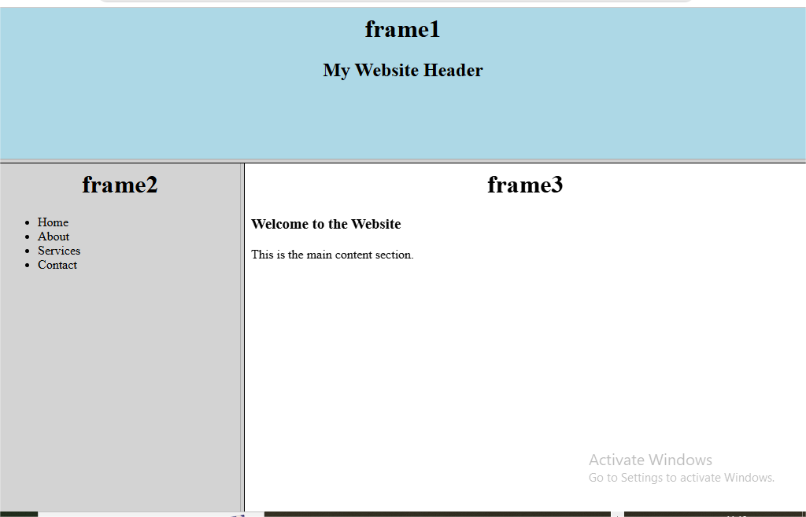

Result: The webpage with one or multiple frames was successfully created using HTML frame tags. The browser window was divided into different sections and each frame displayed a separate HTML document correctly.
Conclusion: HTML frames allow a webpage to be divided into multiple sections where different webpages can be displayed simultaneously. Using frame tags a structured and organized webpage layout can be created effectively.

